Spectral coherence: NZDUSD and USDCAD
Method 21 / daily log returns / Welch magnitude-squared coherence / Alpari D1 full available history

Study setup
Logical pair: NZDUSD , USDCAD
Broker symbols: NZDUSD_i , USDCAD_i
Snapshot: 2026-11-03_majors_alpari_D1
Timeframe: D1
Matched return window: 1999-01-05 to 2026-11-02 (UTC bar dates)
Matched return count n: 7190
Dropped unfinished last bar dated 2026-11-03 UTC after a tick-volume check against the prior complete day.
Welch: fs=1.0, nperseg=256, noverlap=128, window=hann, detrend=constant
Headline: gamma^2 nearest f=1/5; also 1/21 and 1/63
Complete matched rows (Excel): NZDUSD-USDCAD_Spectral_D1.xlsx
Complete matched rows (HTML table): NZDUSD-USDCAD_Spectral_D1_data.html

Method carried forward
Magnitude-squared spectral coherence gamma^2(f) measures shared linear power between matched daily log returns of close, ln(close_t / close_t-1), at each frequency f (cycles per day). Quotes are not inverted. Welch settings are frozen: fs=1, nperseg=256, noverlap=128, window=hann, detrend=constant. Headline is gamma^2 at the frequency bin nearest f=1/5 (five-day cycle from the formula sheet). Also reported: gamma^2 nearest f=1/21 and f=1/63, mean gamma^2 over the frequency grid, and phase of the cross-spectrum at the 1/5 bin. Coherence is unsigned (0 to 1); phase carries timing. Same-sample Pearson r is a side check only. This is not causation and not a trading signal.

Results (headline)
gamma^2 near 1/5: 0.222825
bin f (1/5): 0.199219
phase at 1/5 (rad): -2.935569
gamma^2 near 1/21: 0.420405
gamma^2 near 1/63: 0.340483
mean gamma^2: 0.353694
Pearson r: -0.587831

Target-frequency summary
period | target_f | f_bin | gamma2 | phase_rad
5 | 0.2 | 0.19921875 | 0.22282548 | -2.9355691
21 | 0.04761905 | 0.046875 | 0.42040459 | -2.9607842
63 | 0.01587302 | 0.015625 | 0.34048325 | -3.016767

Conclusion
Headline gamma^2 near f=1/5 for NZDUSD and USDCAD: 0.2228 (bin f=0.199219, phase=-2.9356 rad). At ~1/21: 0.4204; at ~1/63: 0.3405. Mean gamma^2 = 0.3537. Pearson r = -0.5878. This is frequency-domain linkage, not a trading signal.

Charts
Daily closes

Daily log returns

Spectral coherence gamma^2(f)
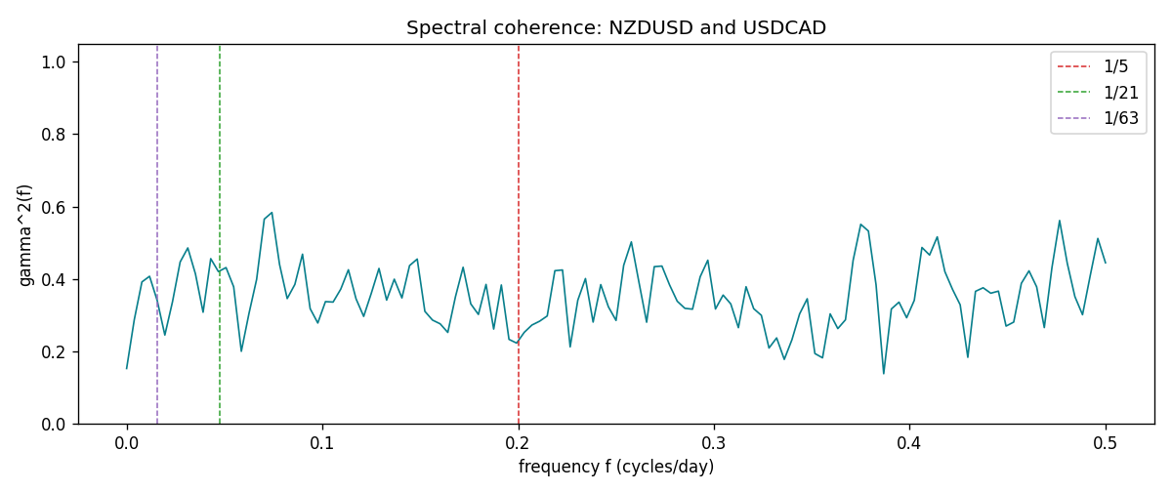

Data report
Matched rows and the coherence sheet are in the sibling Excel workbook named NZDUSD-USDCAD_Spectral_D1.xlsx. Embedding all rows as a Word table is impractical; this file holds column summaries and the first and last 15 matched rows.
Columns: time, NZDUSD_open, USDCAD_open, NZDUSD_high, USDCAD_high, NZDUSD_low, USDCAD_low, NZDUSD_close, USDCAD_close, NZDUSD_tick_volume, USDCAD_tick_volume, NZDUSD_spread, USDCAD_spread, NZDUSD_real_volume, USDCAD_real_volume, NZDUSD_log_return, USDCAD_log_return
Column summaries (matched calculation rows)
column | count | mean | std | min | 25% | 50% | 75% | max
NZDUSD_open | 7190 | 0.6563919 | 0.10821436 | 0.3913 | 0.5912925 | 0.6684 | 0.7249075 | 0.88218
USDCAD_open | 7190 | 1.2668559 | 0.16897553 | 0.9168 | 1.118445 | 1.298545 | 1.37213 | 1.6183
NZDUSD_high | 7190 | 0.66030697 | 0.10871111 | 0.3961 | 0.5947025 | 0.67202 | 0.72936 | 0.88421
USDCAD_high | 7190 | 1.2717549 | 0.16892987 | 0.9336 | 1.122975 | 1.30394 | 1.37655 | 1.619
NZDUSD_low | 7190 | 0.65270307 | 0.10781082 | 0.3897 | 0.5880525 | 0.664185 | 0.720965 | 0.87988
USDCAD_low | 7190 | 1.2623003 | 0.16901312 | 0.9056 | 1.114125 | 1.293585 | 1.36785 | 1.6102
NZDUSD_close | 7190 | 0.65646372 | 0.10821182 | 0.3907 | 0.5915625 | 0.66842 | 0.725015 | 0.8822
USDCAD_close | 7190 | 1.266877 | 0.16895077 | 0.916 | 1.118165 | 1.298615 | 1.372425 | 1.6137
NZDUSD_tick_volume | 7190 | 68672.777 | 123109.57 | 16 | 5561.25 | 33864.5 | 58508 | 1127682
USDCAD_tick_volume | 7190 | 80995.8 | 147287.89 | 37 | 5534 | 40938 | 71622.5 | 1410818
NZDUSD_spread | 7190 | 30.299444 | 25.655426 | 0 | 9 | 17 | 50 | 80
USDCAD_spread | 7190 | 23.448679 | 18.267866 | 0 | 9 | 17 | 40 | 60
NZDUSD_real_volume | 7190 | 1.6692087e+10 | 8.4955308e+10 | 0 | 0 | 0 | 0 | 2.705649e+12
USDCAD_real_volume | 7190 | 1.8371592e+10 | 9.6675129e+10 | 0 | 0 | 0 | 0 | 2.5751613e+12
NZDUSD_log_return | 7190 | 6.02e-06 | 0.00764513 | -0.07027433 | -0.00425619 | 0.00022347 | 0.00457637 | 0.05966839
USDCAD_log_return | 7190 | -9.38e-06 | 0.0051433 | -0.03859748 | -0.00283202 | 5.381e-05 | 0.00272817 | 0.03436319
First 15 matched rows (selected columns)
time | NZDUSD_log_return | USDCAD_log_return
1999-01-05 | -0.0018597736 | -0.010131666
1999-01-06 | 0.0020455609 | -0.0003306769
1999-01-07 | 0.0062963171 | 0.0015202092
1999-01-08 | -0.00055396548 | -0.0020495197
1999-01-11 | 0.010290425 | -0.0035137769
1999-01-12 | -0.0053157489 | 0.0066194721
1999-01-13 | -0.0099742238 | 0.0045420214
1999-01-14 | -0.00018564931 | 0.0069376546
1999-01-15 | -0.00074294208 | -0.0056905671
1999-01-18 | -0.0018597736 | 0.00098344542
1999-01-19 | 0.0018597736 | 0.002748513
1999-01-20 | 0.0040793678 | -0.0059646885
1999-01-21 | 0.0040627941 | -0.0042823796
1999-01-22 | -0.012051689 | 0.0025057712
1999-01-25 | -0.0035504102 | 0.00085579808
Last 15 matched rows (selected columns)
time | NZDUSD_log_return | USDCAD_log_return
2026-10-13 | 0.0047326165 | -0.0046395653
2026-10-14 | -0.0037306483 | 0.0015184751
2026-10-15 | 0.0047634855 | -0.0036101503
2026-10-16 | 0.0057501001 | -0.0034322068
2026-10-19 | 0.0018917133 | -0.0018835331
2026-10-20 | 0.0037199341 | -0.0037066008
2026-10-21 | 0.0030923331 | -0.00084691787
2026-10-22 | -0.0033035227 | -0.0026307268
2026-10-23 | 0.0030929853 | 2.85545e-05
2026-10-26 | -0.0028993932 | 5.7106554e-05
2026-10-27 | -0.00026399852 | 0.0025379458
2026-10-28 | -0.0097283914 | -0.0038379274
2026-10-29 | 0.00062190714 | -0.00011436495
2026-10-30 | 0.00019537668 | -0.0010298736
2026-11-02 | -0.0025962955 | 0.00061519094
First 15 frequency bins
f | gamma2 | phase_rad | period_days
0 | 0.15260704 | 3.1415927 | inf
0.00390625 | 0.28734687 | 3.095997 | 256
0.0078125 | 0.3917923 | 3.0374077 | 128
0.01171875 | 0.40743077 | 3.0555187 | 85.333333
0.015625 | 0.34048325 | -3.016767 | 64
0.01953125 | 0.24505966 | -3.0068939 | 51.2
0.0234375 | 0.33706725 | -3.0554596 | 42.666667
0.02734375 | 0.44697577 | -3.1313685 | 36.571429
0.03125 | 0.48576395 | -3.0242719 | 32
0.03515625 | 0.41400752 | -2.8514026 | 28.444444
0.0390625 | 0.30811947 | 3.048762 | 25.6
0.04296875 | 0.45614796 | -3.0691532 | 23.272727
0.046875 | 0.42040459 | -2.9607842 | 21.333333
0.05078125 | 0.43150537 | -2.9798199 | 19.692308
0.0546875 | 0.37829735 | -2.9343696 | 18.285714

